****

**Repair Order Form  
Highlight the form where your item requires repair. It can be more than one area on the suit.**

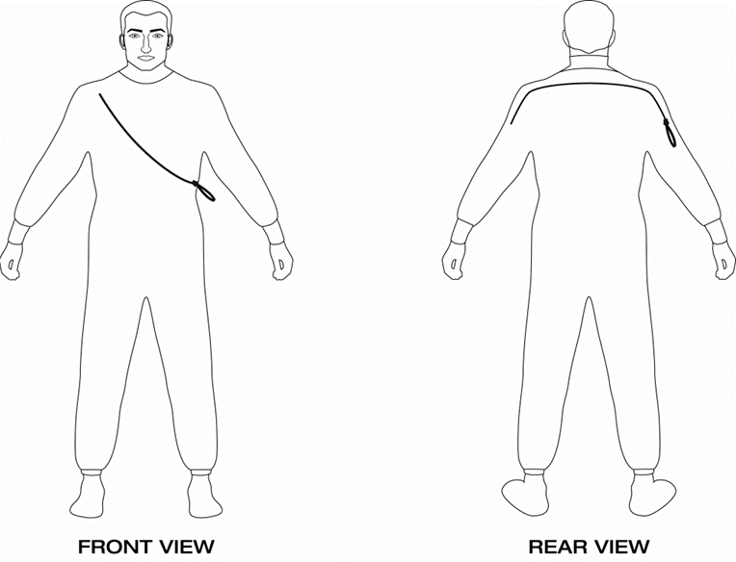

Name -…………………………………………………………………….

Phone……………………………………………………………………..

Email…………………………………………………………………

Address…………………………………………………………………

Fault description -………………………………………………………

Suit make -………………………. Size - …………………………….