Repair Address Label
Complete the address label below, tape to your parcel and post to us.
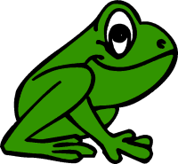
Hoppy’s Drysuit Services-Aberdeen Drysuit Repairs
5 Collieston Place
Bridge of Don
Aberdeen
AB22 8US
Sender:

